UDF with DataFrame

1. Change firstname, lastname columns into

Mr.first_two_letters_of_firstname<space>lastname

for example - michael, phelps becomes Mr.mi phelps

Data is already loaded in sportData Data frame in previous assignment.

* Create UDF to concate name first name and last name according to the given condition.

def udfFullName=

org.apache.spark.sql.functions.udf((firstName:String,lastName:String) =>

{val initial=firstName.substring(0,2);

"Mr."+initial+" "+lastName

})

* Drop first name lastname and add new column with new UDF

val fullName=sportData.withColumn("Full Name",udfFullName(sportData("firstName"), sportData("lastName"))).drop("firstName").drop("lastName")

* Show data of final UDF

fullName.show()

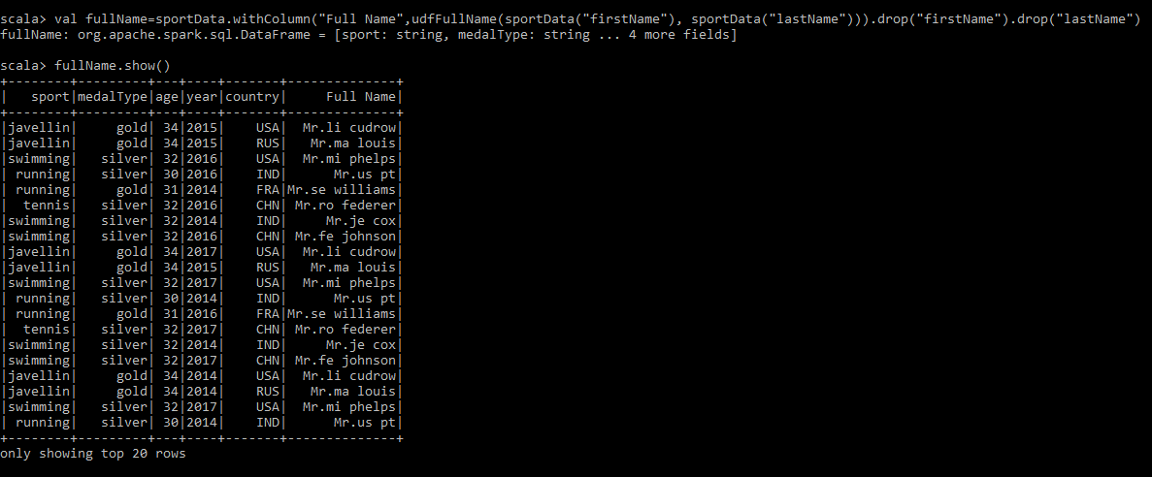

1. Add a new column called ranking using udfs on dataframe, where :

gold medalist, with age >= 32 are ranked as pro

gold medalists, with age <= 31 are ranked amateur

silver medalist, with age >= 32 are ranked as expert

silver medalists, with age <= 31 are ranked rookie